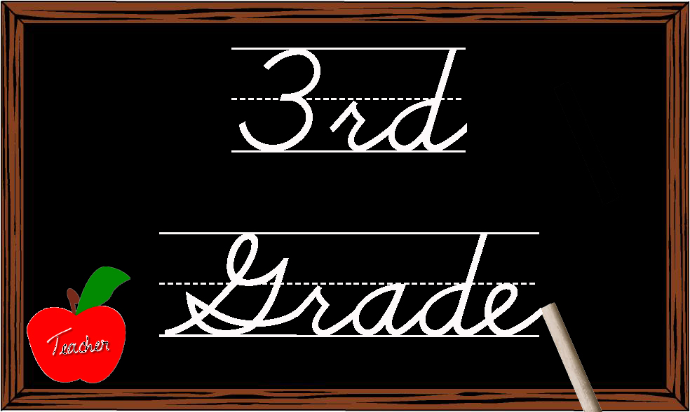

August 7, 2017

Dear Third Grade Parents and Guardians,
Welcome back to another school year. We are so glad that you are with us in third grade at Highland School. It is a great place to be! The third grade teachers wanted to provide you with an outline of what to expect as we begin this school year. More information will be provided to you throughout the school year as it is relevant to you and your child. The third grade teachers use a weekly newsletter and a third grade website, www.highlandthirdgrade.weebly.com , to keep you up to date on all activities and events. We are so happy to work with you and your child for a wonderful third grade year!
Curriculum: The third grade teachers collaborate as a team to plan, create, and implement lessons and units throughout the school year. We are following the EVSC Curriculum Maps which are derived from the Indiana State Standards as our yearlong plan for all subject areas. By following the EVSC Maps, students may not completely use the third grade textbooks and workbooks from cover to cover. Skills and standards are taught as they are sequentially organized on the EVSC Maps and not as they are listed in the textbooks. Textbook companies produce textbooks for use throughout the country and do not tailor them to our specific needs in our state or our district. You may notice that supplemental resources are used in addition to the provided textbooks and workbooks. Textbooks and workbooks will be used as much as possible as long as they align with the Indiana State Standards and the EVSC Maps.
Standardized Testing: Students in third grade will participate in standardized tests for the first time. In the spring, students will take ISTEP+ and IREAD. ISTEP+ tests students on the Indiana State Standards within the subject areas of English/Language Arts (E/LA) and mathematics. E/LA skills include reading comprehension, vocabulary, grammar, and writing. It also tests mathematics skills like number sense, computation, algebraic thinking, data analysis, geometry, and measurement. The applied skills format in both subject areas will ask students to write out answers with explanations to show their thinking. The multiple choice format asks students to choose the best answer for each question provided. Students also take the IREAD test which tests reading only. This test assesses reading comprehension, phonics, and vocabulary skills which were taught in previous grades and are reinforced in third grade. If a student does not pass IREAD, that student will need to attend a summer remediation program and retake the test in the summer. If a student does not pass the summer retake opprotunity, that student will repeat third grade the following year.
Tracking Progress: To assist teachers in tracking student progress throughout the school year, the third grade teachers use a variety of measures provided to us by the state and the EVSC. One measure used three times a year is called NWEA. It is used to track progress in reading and math. Teachers will also administer individualized testing in reading comprehension and fluency. Current reading levels will be communicated with parents throughout the school year.

Classroom Tests: The third grade teachers are also using teacher created tests to assess student achievement during our units of instruction based on the Indiana State Standards. Students may take short assessments at school that will not be graded and used only to inform teacher instruction regarding how students will proceed within a unit of instruction. At the end of a unit of study students will take a unit test that will be graded and used when calculating final grades for each subject. These tests will be sent home. Students will be asked to reflect on their work and set goals for themselves as the year progresses. We encourage parents to track your child’s progress by using the RDS Parent Access system. Please email parentaccess@evsc.k12.in.us to receive your activation code.
Spelling: Traditional spelling programs often reinforce random memorization of words with no transfer to daily student writing. This year, the third grade team will use a practical spelling program that will enable all students to become confident spellers and writers. Students will participate in various activities to reinforce spelling patterns and homophones. Key words will be placed on the word wall in each classroom. Students will be accountable for spelling these words correctly in their writing. Every three weeks students will be tested on ten words within writing.
Homework: It is very important to develop study habits that will assist your child in a successful school year. First, reading and math homework will be sent home on Monday each week. Students should complete this work at home and return it to school by Friday each week. Second, your nightly routine should include 20 minutes of reading to and with your child. Third, students need to practice their math facts at home throughout the week in order to strengthen their computation skills. At this time students should have mastered their addition and subtraction facts and work to master their multiplication facts through the year. Finally, students need to be sure to use provided study guides and review work sent home as study aids to prepare for unit tests.
Science and Social Studies: In the third grade curriculum, science and social studies are not taught simultaneously each day. Students will spend approximately 4-5 weeks on social studies and 4-5 weeks on science each grading period for a total of nine weeks between the two subjects. Students will engage in science activities and notebooking tasks as they work through investigations in topics such as weather, animals, invisible forces, and plants. Students will use a combination of textbook resources and engaging activities for social studies as they learn about our geographical world, our country, our economy, and our community. Science and social studies are only graded on the report card in the second and fourth grading periods with marks of E (Excellent), S (Satisfactory), or N (Needs Improvement). Scores will be accumulated throughout a semester and averaged for those grades.
We work closely as a team to plan and make sound educational decisions for all third grade students. Your support in and out of the classroom is appreciated. Working together we can all look forward to a successful year!
Sincerely,
The Third Grade Teachers

